Garners Field Campsite Self Supporting Tower

Climbing & Abseiling Tower

Operating Procedure

Version 1.6
October 2023

For the purpose of this document the names Self Supporting Climbing Wall and Climbing Tower are interchangeable.

Location of compound using the application:

///what3words

///flicked.flinches.clipboard
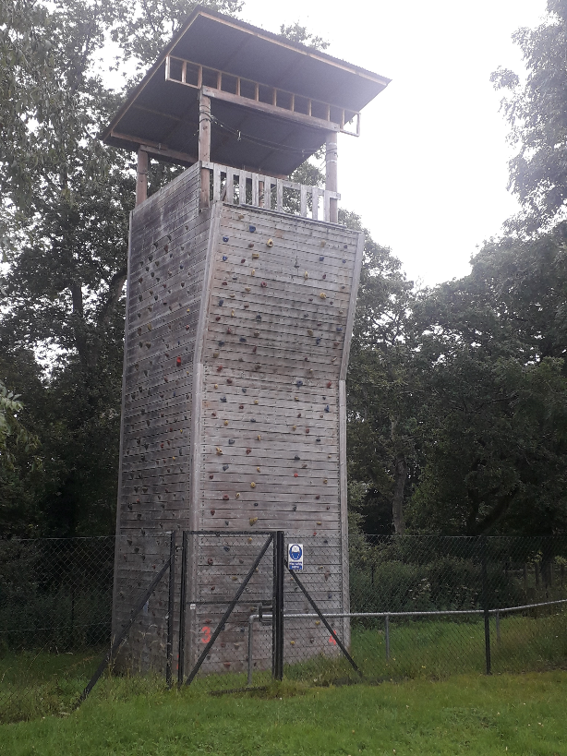

Picture 1
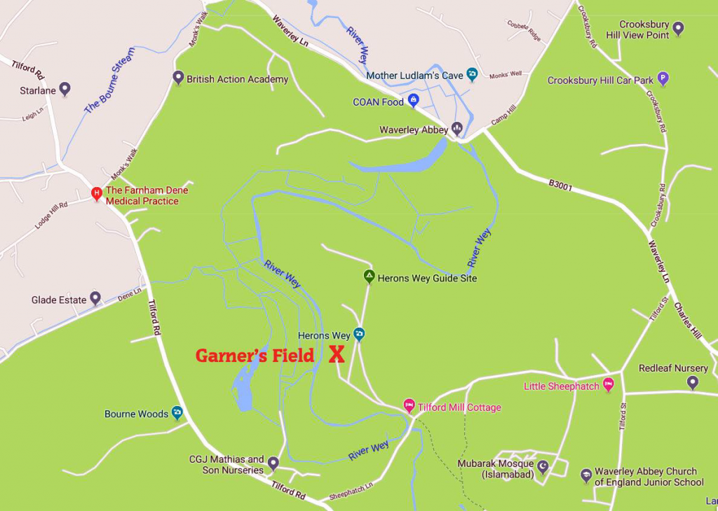

Picture 2

Document Control

Version | Changes | Author | Date | Approver | Date
1.0 | Document creation | William Weller | 01/07/21
1.1 | Document reviewed | William Weller, Tom Lisle | 09/08/21
1.2 | Document District review | Farnham District Commissioner | 09/08/21
1.3 | Emergency access plan added | William Weller | 26/09/21
1.4 | Gearlog.org 4.4 equipment log added | William Weller | 28/02/22
1.5 | Document tidy up, extra Abseiling process on two Adults needed | Andrew Kite | 14/10/22
1.6 | 2023 Annual review plus addition of section on Lead Climbing | Andrew Kite | 17/10/23 | William Weller & Tom Lisle | 23/10/23

Table of Contents
1. Document Control 3
2. Table of Contents 4
3. Definition and Scope of the Activity 5
4. General Information 6
4.1 Instructor Qualifications 6
4.2 Instructor 6
4.3 Climbing 6
4.4 Abseiling 6
4.5 The Site 7
4.6 Equipment 7
4.7 Setting up the tower 8
4.8 Restrictions 8
4.9 Accidents 8
4.10 Garners Field Campsite Accident and Emergency Procedure 8
4.11 Weather conditions 9
4.12 Risk Assessments 9
5. Running the Session 11
5.1 Prior to commencing any activity 11
5.2 Equipment required by participants and instructors 11
5.3 During the Activity 11
5.4 If peer belaying is being used 12
5.5 After the activities have ended 12
6. Set Up Instructions 13
6.1 Ground Anchor 13
6.2 Top rope Set-Up 14
6.3 Belay Set Up 15
6.4 Live End 16
6.5 Abseil set up 17
6.6 Abseiling 18
7. Emergency Rescue Plan 19
8. Additional Activities 20
8.1 Night Climbing and Crate Stacking 20
8.2 Lead Climbing 20

Definition and Scope of the Activity

Climbing and abseiling takes place on a purpose-built wooden Self-Supporting Climbing Wall located at Garners Field Campsite.

The wall has three working sides

Climbs 1 and 2 on a straight wall
Climbs 3 and 4 on a straight wall with overhang
Abseiling wall, which can also be used for crate stacking activities

General Information

Instructor Qualifications

The following qualifications can be used for this activity (or equivalent qualifications)

- Climbing Wall Instructor, Supervisor with Abseil (CWI) or higher
- Girlguiding Level 1 Climbing/Abseiling
- The Scout Association Climbing/Abseiling Permit (Leadership or above)

A copy of the instructor’s qualification must be attached to the Garners field booking procedure prior to a session taking place, if using non-Farnham District instructors. This will be kept on file for future reference. If using district instructors, then compass records will be checked prior to approval.

If the tower is hired as a self-led activity, the leader in charge of the group assumes responsibility for the safe set up and running of the activity. If at any time a campsite warden or District climbing team member is concerned about the way a session is progressing, the session will be stopped.

Instructor

Climbing

- Where there is more than one qualified climbing instructor on a session, one must be designated to be the person in charge of the session or supervisor.
- No more than two climbing ropes can be supervised by a single climbing instructor.

Abseiling

- Abseiling will be operated by a suitably qualified Abseil instructor. A climbing instructor can NOT operate the abseil wall. When running abseiling there must also be a supervising adult, in addition to the abseil instructor, at the top of the tower. The Supervising Adult is there to ensure participants waiting to abseil do not move past the metal barrier until called forward by the abseil instructor, and do not disturb the abseil instructor in any way whilst the instructor is operating the abseil. The supervising adult does not require a climbing qualification to perform this task.
- If someone has refused to abseil for any reason, and are in a distressed state, they must be safely escorted down the internal staircase to a safe place by the supervising adult. If escorting the person down results in no supervising adult at the top of the tower then the abseiling activity should be put on hold until a supervising adult is back at the top of the tower.

The Site

- The tower compound is to be kept locked when unattended.
- The structure must be inspected and certified by an approved contractor annually in accordance with EN 15567-1 2007 and EN 15567-2 2007

Equipment

- All equipment must be inspected by a competent nominated district climbing supervisor at the beginning and end of every outdoor climbing season. This is logged on a website – gearlog.org – with details of purchase date and serial numbers. A copy can be accessed by the climbing team.
- Ropes must be checked every use for general wear and tear. Helmets and harnesses must be checked before fitting.
- All participants and instructors must wear a helmet and sit harness. If the participant has an ill-defined waist (i.e. a standard sit harness will not be sufficient to provide safety when climbing or abseiling), a full body harness or a linked sit and chest harness must be worn if available. If a harness cannot be fitted safely then that person will not be able to climb or abseil.
- All equipment must be purchased from reputable retailers and conform to the appropriate safety standards.

  - Helmets EN 12492
  - Harnesses EN 12277
  - Ropes
    - Dynamic EN 892
    - Low Stretch EN 1891
  - Carabiners EN 12275
  - Belay Devices EN 15151-2
  - Slings EN 566

- Any damaged equipment must be removed from use and hung on the labelled ‘Quarantine’ pegs in the tower store and recorded, tagged and district climbing team must be informed.
- Climbing equipment will be replaced in accordance with manufacturer guidelines and scouting POR.
- If an instructor wishes to use their own harness and helmet this must be approved by the lead instructor running the event.
- Participants on a district led session are not permitted to use their own equipment unless agreed by the supervisor.
- Where outside groups have hired the tower only with no equipment, the responsibility for the safety and suitability of their equipment rests with the group leader in charge. If the campsite wardens or a member of the Farnham district climbing team feel the equipment or operation is unsafe, the session will be stopped, and the equipment investigated with the leader in charge.

Setting up the tower

Climbing Activity will be set up in accordance with the set-Up Instructions as detailed in this document. A copy of these set up instructions are also displayed inside the climbing equipment store.

If you have any questions, please speak to the campsite warden or District climbing team.

Restrictions

Maximum weight of an individual using the facility is limited to 120Kg (19 stones).
There is no limit on Height, though it is important that people can duck under the horizontal steel support wire between eye bolts when starting to abseil. Minimum height is set by use of our smallest full body harness.
A maximum of 10 people can be on the tower platform at any one time, including instructors.

Accidents

If any accidents or first aid takes place as part of the activity, the group leader hiring the session must be contacted. All groups hiring must have their own first aid kit on site. Farnham District have provided a first aid kit inside the tower.

An accident form must be completed as soon as possible before the end of the working day – there is a pad inside the tower. Out of District groups hiring the activity must keep and retain their own forms. In District Groups must complete one that is kept in the locked filing cabinet inside the hall office in line with to current GDPR procedures.

The activity must be stopped while the first aid incident is taking place unless there are enough qualified personnel to continue to run the activity safely and manage the Accident. If the activity needs to be stopped all climbers and abseilers must be lowered to the ground immediately.

Garners Field Campsite Accident and Emergency Procedure

Garners Field Campsite Accident and Emergency Procedure must be followed:

SUMMONING EMERGENCY SERVICES
Instructions for finding Garner’s Field Campsite
Garners Field Campsite is located towards the end of a tarmac single lane branching off Sheephatch Lane near Tilford village, about 3 miles south of central Farnham.
The tarmac track to the Campsite starts beside ‘Tilford Mill Cottage’ ///lawns,rainy.glows post code GU10 2AQ which is situated adjacent to ‘Old Tilford Mill Bridge’. Emergency Services should be made aware that if coming from the Farnham or Tilford direction via Tilford Road into Sheephatch, they will need to cross this narrow bridge which has a weight restriction of 7.5 tons. Once on the Campsite Lane – do not take the first right into ’Herons Way’ Girl Guide Campsite but carry straight on. Go past the small holding entrance to the right and just beyond is the entrance to Garner’s Field ///fastening.drones.sings on the right. Sheephatch Lane to Garner’s Field entrance along the Campsite Lane is about ¼ mile.
In an emergency it is recommended to send a responsible person along the Campsite Lane to the main entrance of Sheephatch Lane to direct any arriving emergency vehicles. At night wear a high viz jacket and carry a light if possible.

Weather conditions

The instructor must check the weather conditions prior to starting the activity. The campsite warden or District climbing team will inform the instructors of any conditions that might stop the activity.

The activity must not take place in the following conditions

- Electrical storms
- Very high winds
- Very heavy rain
- Any other condition the instructor in charge deems unsafe

If thunder or lightning is witnessed locally then activities must stop and wait 20 minutes before proceeding after the last thunder was heard.

Instructors must inform the campsite warden or district climbing team if the activity has been stopped due to weather conditions.

The qualified instructor has the final say in whether an activity takes place or must be terminated.

Risk Assessments

The site risk assessment document must be read in conjunction with the activity risk assessment document provided by the operator.

A risk assessment hard copy can be found inside the tower and a soft copy can be found on the district campsite website.

Instructors must have read this document and the risk assessment for this activity before they instruct this activity.

This document and the risk assessment are regularly updated. The campsite warden or district climbing team will update instructors of any changes to these documents. Instructors must ensure that they have read these changes.
Any Group / Section using the climbing tower, whether with Farnham District climbing instructors or their own climbing instructors, must also complete their own additional risk assessment specific to the people involved in their own group.

Running the Session

Prior to commencing any activity

The instructor in charge of the session is responsible for checking the equipment is set up correctly, regardless of who set the activity up.

The following list of tasks are required to be completed before the activity can start

- A visual inspection of the tower must be undertaken during set up of the activity. This is to include looking for any damage and checking the area around the tower is free of debris and other trip hazards.
- The instructor must ensure the tower is set up in accordance with Tower Operating Procedures.
- The instructor must give a clear demonstration to all participants of the correct method of fitting and wearing of all personal protective equipment (PPE).
- The instructor must check the fitting of all participant’s personal protective equipment.
- The instructor must ensure the group are prepared for the session, including correct clothing, footwear, long hair tied back, and jewellery removed.

Equipment required by participants and instructors

Any participant taking part in the activities once beyond the waiting area inside the compound must have the following:

Equipment | Participant | Instructor
Windproof/coat (weather dependant) | ✔ | ✔
Sunscreen/water bottle (weather dependant) | ✔ | ✔
Closed shoes, no crocs or wellies | ✔ | ✔
Harness | ✔ | ✔
Helmet | ✔ | ✔
First Aid Kit | Mounted inside Tower

During the Activity

- There must be at least one adult on the ground to assist with group control and connecting / disconnecting from the equipment. This may be another member of District climbing team or a competent Leader.
- Anyone inside the climbing compound must always wear a helmet.
- There must always be a person attached to the safety system i.e. the belayer, when in use.
- Spectators must stay outside the compound unless agreed by the lead climbing instructor.
- Anyone using Farnham District climbing equipment (harnesses and helmets) may not leave the climbing tower area without first removing all Farnham District equipment and leaving it with a member of the District Climbing team, or supervised kit area (e.g. the canvas sheet normally laid just outside of the access gate to the Climbing Tower).

If peer belaying is being used

- The belaying process must be closely supervised by the instructor.
- Lowering of participants must be carried out under direct supervision of the instructor.
- The safety rope must be tailed at all times, i.e. the tail end.
- There must be a physical check of the climber and belayer(s) before the climber leaves the ground to ensure all equipment is fitted and secured correctly.

After the activities have ended

- Participants must be instructed to leave equipment ready for the next group.
- If there are no other groups, all the equipment must be returned to the climbing store.
- Any defective equipment must be hung on pegs above the ‘Quarantine’ sign. Any wet ropes or harnesses’ to be hung on pegs labelled ‘Wet ropes’ to dry inside the tower store. In either case inform the campsite wardens or contact District climbing team (via email).
- Any accident or incident must be recorded appropriately.
- Equipment must be left tidy and ready for use by the next group
- The Climbing Tower usage log should be filled in with relevant details of the activity
- Ensure nobody is left inside the compound when leaving the activity and lock up the compound to prevent unauthorised access.

Set Up Instructions

The Climbing Equipment is stored in 2 locked grey metal toolboxes within the Climbing Store.

There is one plastic tub for each of the four climbs and these MUST have the rope belayed into them to help avoid the ropes becoming excessively dirty.

Each climb should contain the following

- 1x Dynamic Climbing rope
- 1x Adjustable belay sling
- 1x Steel Maillon
- 1x Belay device, Grigri
- 2x Screw-gate Carabiner
- 1x DMM Belay-master Carabiner (with black clip)
- 1x 30cm Sling

Ground Anchor

Picture 3 below shows the steel Maillon holding the adjustable belay sling to the ground anchor.
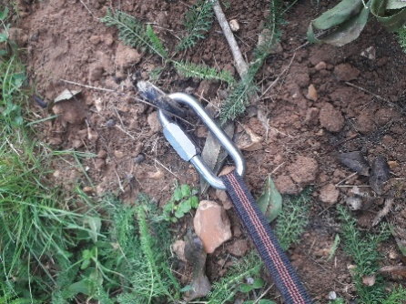

Picture 3

Make sure the gate is screwed shut and the Maillon is orientated with the screw at the lowest point. This helps to prevent the Maillon undoing itself whilst being moved around.

When not in use the Ground anchor is protected by placing a traffic cone over it – this must be replaced for each ground anchor at the end of every climbing session.

Top rope Set-Up

Picture 4 (below) shows the incorrect installation of the top rope

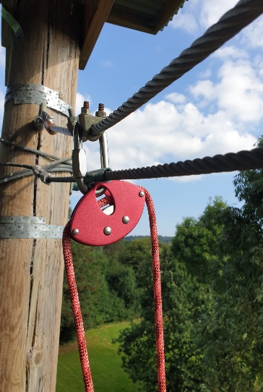
Picture 4

Picture 5 (below) shows the correct installation of the top rope

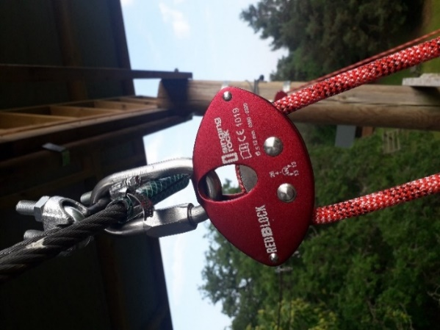

Picture 5

Dynamic rope is passed through the reduction block, one for each of the 4 climbs. The rope must pass through the block under the spacer bars, not over the spacer bars.

Belay Set Up

The belay device should be attached to the climbing rope as shown in Picture 6 below. The end of the rope used to pass through the belay device must be the one coming from the end of the reduction block facing outwards from the climbing tower.

The screw gate of the carabiner should be on the left of the device as this makes tying off the device easier. Ensure the carabiner is oriented in such a way that gravity helps keep the screw in place, as shown.

The extra carabiner on the short 30cm tape is for the belayer to clip into their harness. For clarity, the clip for the belayer is purely as a reminder to the person belaying that they need to focus. It is not in itself a part of the safety system for the climber.

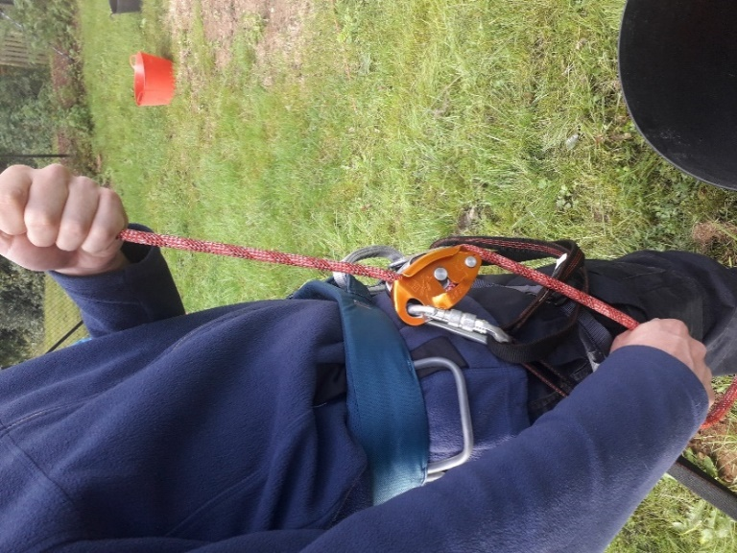

Picture 6

Live End

The belay master carabiner should be clipped to a neat figure of 8 knot with a stopper knot above as shown in picture 7 below. The loop in the figure of 8 should be small enough that a climber cannot put their hand through it.

The end of the rope used as the live end must be the one coming from the end of the reduction block facing inwards from the climbing tower. Avoid twisting the rope to ensure the rope runs through the reduction block smoothly.

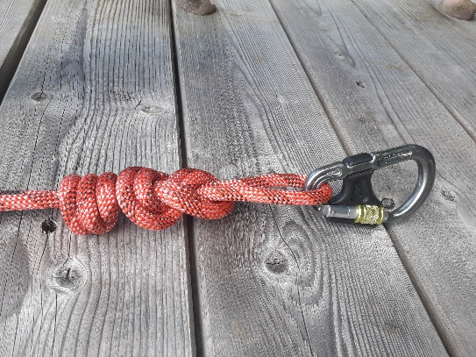

Picture 7

Abseil set up

The static (black) rope must be fixed to a large carabiner, which is itself attached to the 120mm Maillon, using an Italian hitch and 3 half hitches.

The safety (dynamic) rope must be threaded through the figure 8 hung on a carabiner from the swivel device, with figure 8 knot tied at each end plus stopper knot, and a carabiner attached at each end to clip to the abseiler.

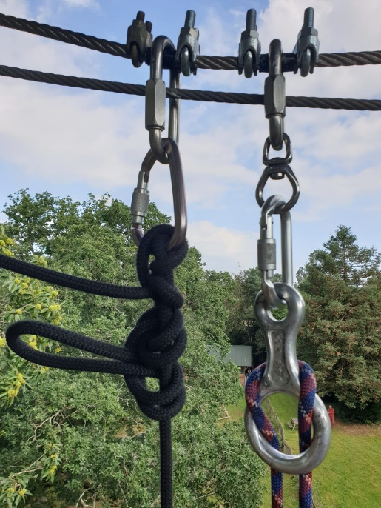

Picture 8

Abseiling

- When instructed, the participant must climb up the tower to the platform at the top carrying a descender device (figure of 8 plus carabiner). This is our key golden rule.
- On reaching the top the stairs a supervising adult or abseil instructor will clip the participant into the overhead hanging tape. The participant will then wait for further instructions.
- When it is a participants’ turn to abseil, the abseil instructor will fit the safety rope and abseil (static) rope and explain the process of abseiling.
- The Participant disconnects from the safety and abseil rope once they have reached the floor. Ideally a supervising adult performs these tasks for the abseiler.

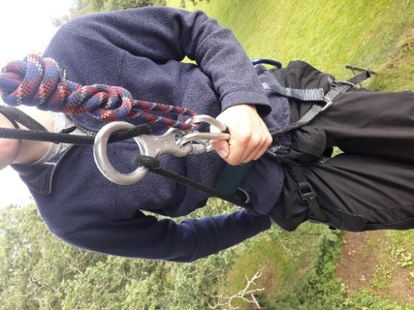

Picture 9

Emergency Rescue Plan

Should an incident occur whilst using the facility e.g. a climber’s foot gets caught on a hold and they are suspended upside down, there are several options to be considered by the lead instructor.

- Pull the climber up by the top rope until able to release the foot.
- An instructor climbs up the adjacent climb on a belay and assists the climber.
- Get the double ladder from the pioneering store, ascend as far as needed, roped up, to assist. Ensure the ladder is in a position where it cannot slip and injure any party.
- If needed, an extra rope could be set up and a qualified climber could then abseil down to assist.
- In the event of a serious incident call the emergency services.

If an incident occurs whilst abseiling, then the abseiler is lowered with the safety rope after releasing the Italian hitch and dropping the static rope to the ground.

Additional Activities

Night Climbing and Crate Stacking

Night operation is an additional activity and will require its own risk assessment and procedure in addition to this document, covering lighting and the additional requirements of running the event in the dark.

Crate Stacking is an additionally activity and will require its own risk assessment and procedure.

Lead Climbing

Climb 4 includes stainless steel bolt hangers which are used for Lead Climbing (see picture 10 below). When not in use the stainless steel bolt hangers have a plastic insert for safety purposes. Lead Climbing is an activity only for use by the District climbing team, and is not covered as an activity in this operating procedure (i.e. this activity is not covered within the existing operating procedures and risk assessment for the climbing tower, and is not an activity we offer to Groups booking the tower).

When doing a safety briefing for the standard climbs, instructors must point out the stainless steel bolt hangers on climb 4 and state that they are not to be touched by climbers under any circumstances.

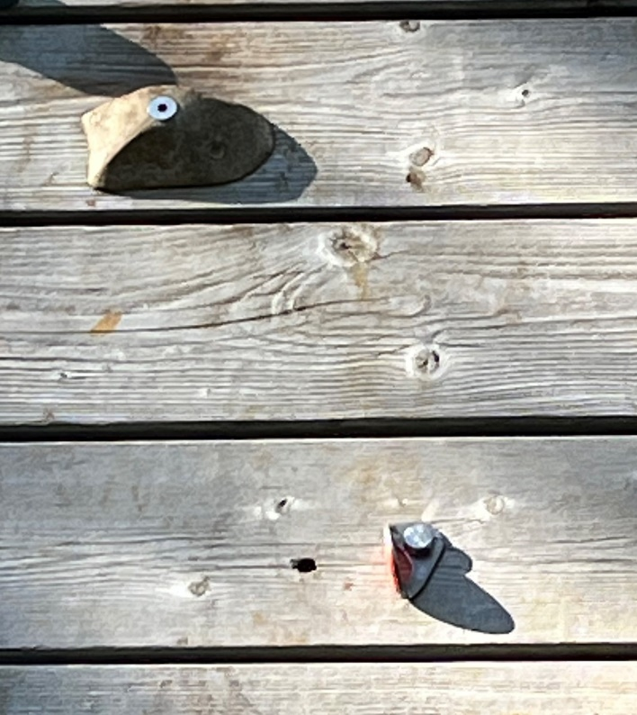

Picture 10

